5. Use Cases
4.1 Use Case Diagram
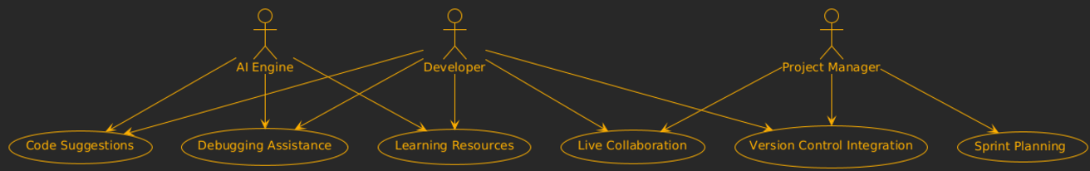
Fig 4.1.1 Use Case Diagram
4.2 Use Case Descriptions
Use Case 1: Code Suggestions
Use Case ID | UC1
Use Case Name | Code Suggestions
Description | The AI engine provides real-time contextual code suggestions to developers, improving productivity and reducing coding errors.
Primary Actor(s) | Developer
Preconditions | - Developer has logged into the platform.  - Active coding environment (IDE) is connected to the system.
Triggers | Developer starts typing code in the IDE.
Main Flow | 1. Developer opens a project in the IDE.  2. AI engine analyzes the context and provides real-time suggestions.  3. Developer selects or ignores the suggestion.
Postconditions | Suggested code snippet is integrated into the developer’s work.
Extensions | If no relevant suggestions are available, the AI indicates and provides general guidance.
Use Case 2: Debugging Assistance
Use Case ID | UC2
Use Case Name | Debugging Assistance
Description | The AI assists in identifying and fixing bugs in the code by providing detailed explanations and suggested solutions.
Primary Actor(s) | Developer
Preconditions | - Code file must be open.  - AI debugging module is active.
Triggers | Developer runs the debugging tool or encounters a code error.
Main Flow | 1. Developer activates the debugger.  2. AI scans the code for syntax errors, logic issues, or potential vulnerabilities.  3. Suggestions for resolving issues are displayed.
Postconditions | Errors are fixed, and the code is re-tested.
Extensions | If AI cannot resolve the issue, it provides recommendations for external resources or expert forums.
Use Case 3: Sprint Planning
Use Case ID | UC3
Use Case Name | Sprint Planning
Description | Provides project managers with tools to plan, organize, and manage sprints effectively using AI recommendations.
Primary Actor(s) | Project Manager
Preconditions | - Team members must be registered.  - A project must exist.
Triggers | Project manager creates or updates a sprint.
Main Flow | 1. Project manager opens the sprint planning module.  2. AI analyzes project goals and team availability.  3. Task allocation and deadlines are suggested.
Postconditions | Sprint plan is finalized and shared with the team.
Extensions | The manager can manually adjust the AI suggestions if required.
Use Case 4: Live Collaboration
Use Case ID | UC4
Use Case Name | Live Collaboration
Description | Enables multiple developers to work on the same codebase in real-time with AI-driven assistance.
Primary Actor(s) | Developer, Project Manager
Preconditions | - Team collaboration mode is enabled.  - Shared workspace is active.
Triggers | Developer or project manager initiates a live coding session.
Main Flow | 1. Collaboration session is initiated.  2. Team members join the session.  3. AI offers coding assistance during live coding.
Postconditions | Changes made are synchronized across all participants.
Extensions | If conflicts occur, AI suggests resolution strategies.
Use Case 5: Learning Resources
Use Case ID | UC5
Use Case Name | Learning Resources
Description | Provides developers with tutorials and personalized learning materials to upskill in real-time.
Primary Actor(s) | Developer
Preconditions | - User account must be active.  - Learning module must be enabled.
Triggers | Developer accesses the learning hub.
Main Flow | 1. Developer selects a learning topic.  2. AI generates context-specific tutorials and materials.  3. Progress is tracked and updated in the user profile.
Postconditions | The developer’s knowledge and skills improve.
Extensions | Developers can request AI mentorship for additional support.

